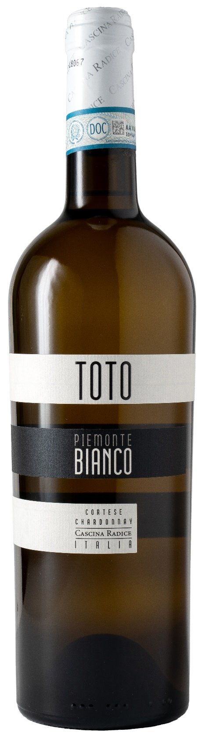
PIEMONTE BIANCO DOC – TOTO

Grape: Cortese, Chardonnay
Alc. Vol.%: 12
Vintage: 2025
Residual sugar g/l: 4,1
Total acidity g/l: 6,1
Region: Piedmont
Production zone: Vineyards in the province of Asti
Capacity: 750ml

CHARACTERISTICS

Vinification: Fermentation at a controlled temperature for 12 days
Aging: 4-6 months in steel tanks
Yield per ha: 11000kg
Soil composition: Clayey marl
Colour: Straw yellow with greenish sparkles
Bouquet: Delicate, fruity and aromatic
Flavour: Fresh and lively with a lingering, pleasant aftertaste

SERVING SUGGESTIONS

Excellent with starters, light pasta dishes and white meat.
Serving temperature 8 °C
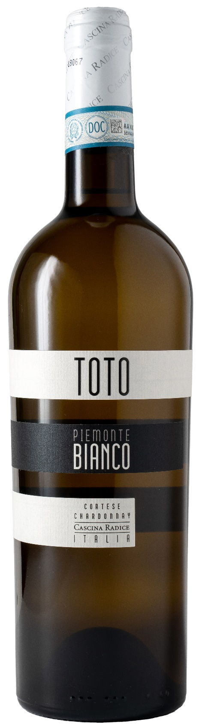
TECHNICAL INFORMATION / PALLETIZING

Size 750ml:
Article Nr. V02013A
GTIN-13 bottle 8017868003700
GTIN-13 carton 8017868003892
Closure Cork
Bottles / carton 6 bottles
Pallet size 80x120cm
Cartons/layer 21
Cartons/pallet 105
Kg/carton 8,1
Kg/pallet 870

Contains sulphites
GMO Free
Revisione 01. 21.04.2026

